- Open a new Excel spreadsheet
- Save this as Personal Budget in your ICT folder

- Enter text as shown below

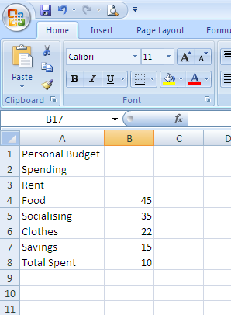

- Widen the columns so you can see all the words
- Format the numbers to number and 2 decimal places
- Use AutoSum to add up the numbers in cell B10
- Insert a row above A5 and insert Mortgage 17
- Insert a header with your name, date and file name
- Save
- Print and close

